

**UNIFIED MENTOR PRIVATE LIMITED**

**Intern name: Kumari Shruti Jha**

**Role: Data Analyst Intern**

**Internship Id: UMIP8809**

**Date of Submission: 15-07-2024**

**Contact Info: Email:**[**Shrunov17@gmail.com**](mailto:Shrunov17@gmail.com)

**Mobile no.: 8789819002**

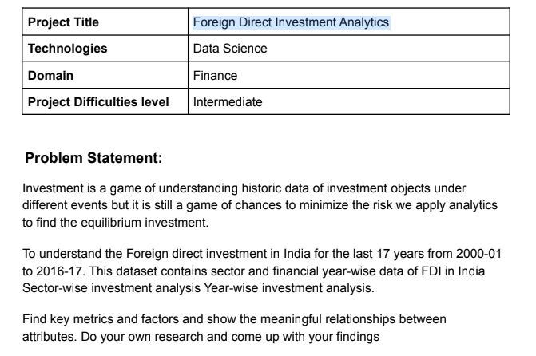

FDI analytics project:

The approach used for analyzing this dataset is threefolds. In the first section I have used regression lines and identified the sectors with the most stable and increasing slope throughout the years, which will basically show good investment opportunities. Based on these regression lines the next foreign investment can be identified.

The second approach is to use correlation between these sectors and identify which sectors are the most correlated. This can significantly show if the data validates the common sense understanding of the most correlated sectors. The least correlated sector has also been identified and then these pairs of correlated sectors have been plotted on the same plot along with their regression lines. I believe this will give extremely significant insights into the flow of FDI into Indian Markets.

The third approach is a clustering-based approach which basically tries to use kmeans clustering and identify potential clusters of sectors based on their historical FDI. This would show the clusters attracting the most FDI throughout the years and provide more insight to a customer looking to invest.

These approaches when combined together will give important insights into the investment opportunities and risks involved in particular sectors.

1. Regression Analysis:

This will identify the sectors with the most stable and increasing slope

First the sectors with the most positive regression:

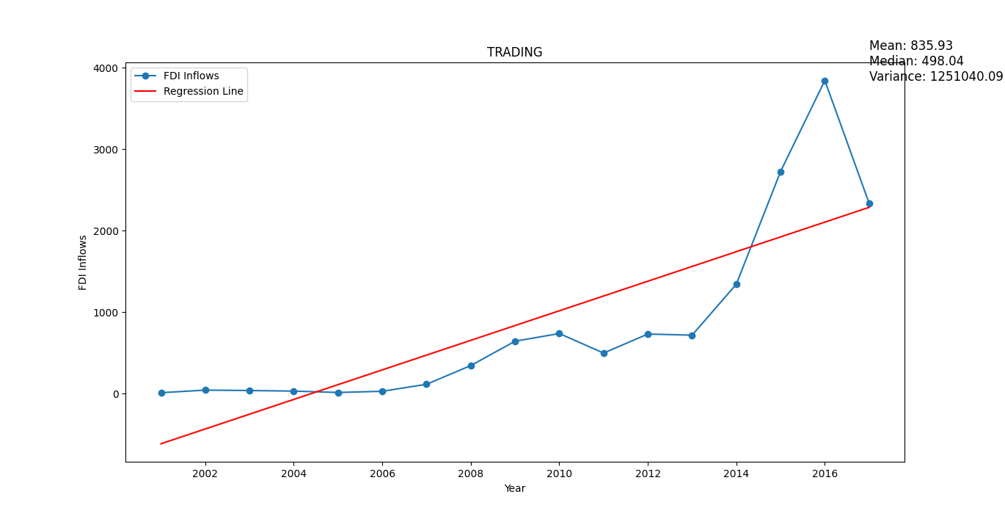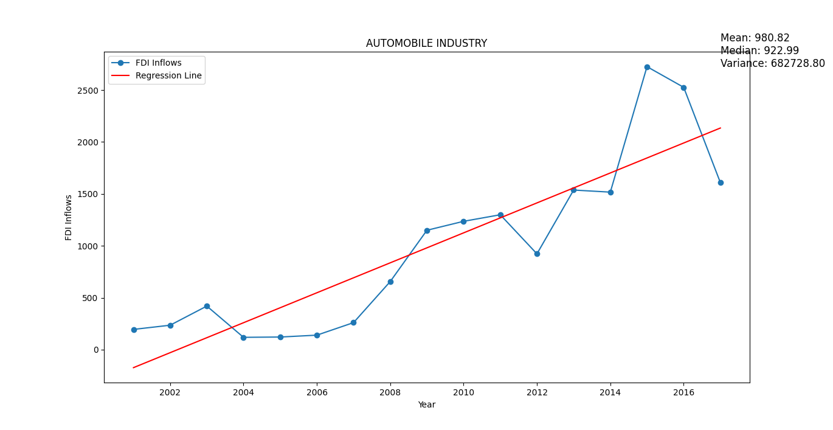

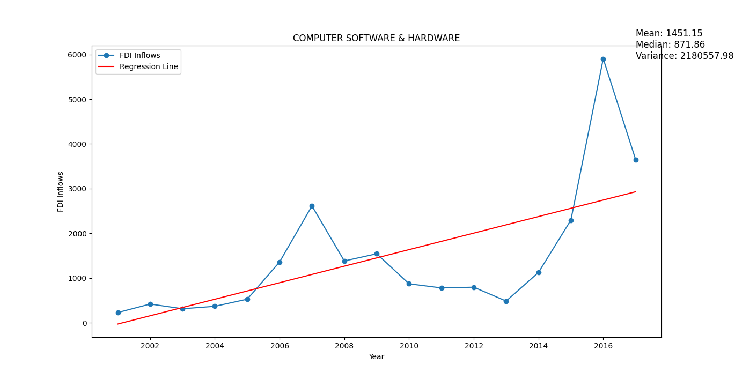

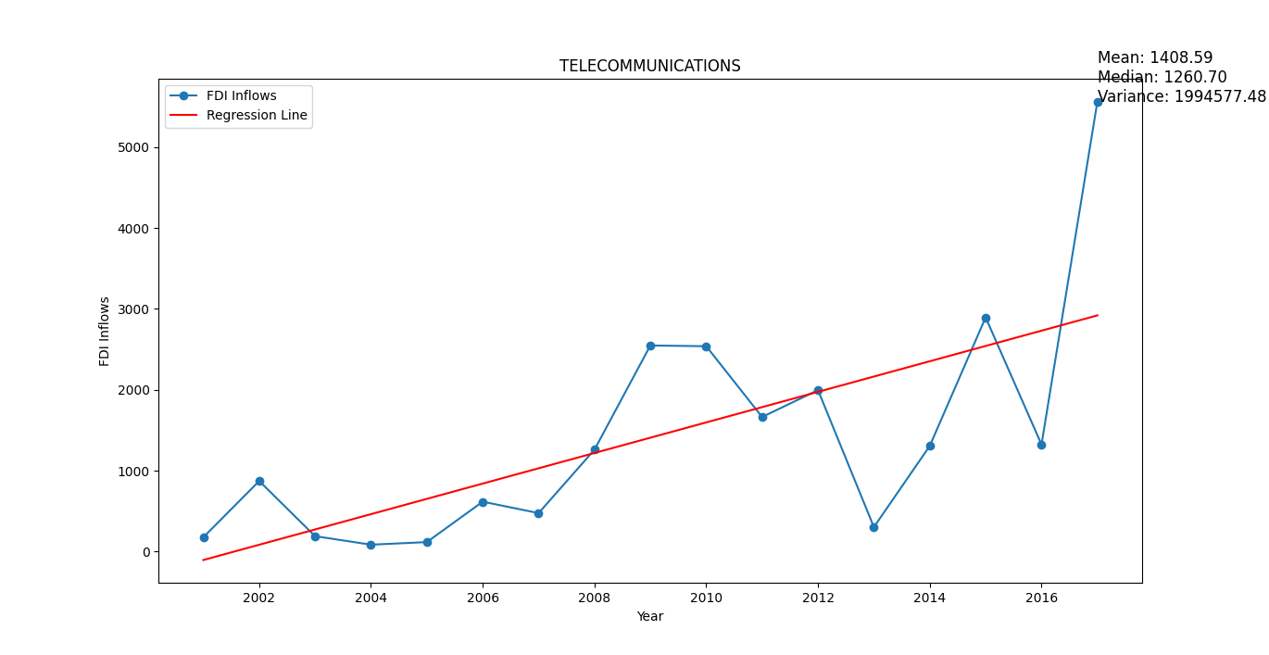

Now for the sectors with the decreasing slope: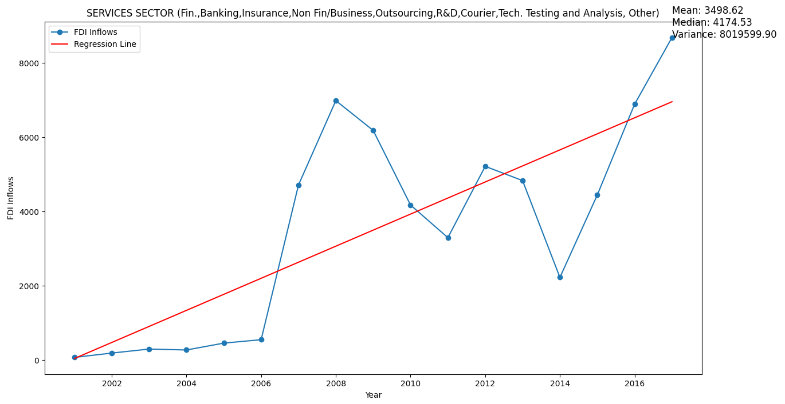

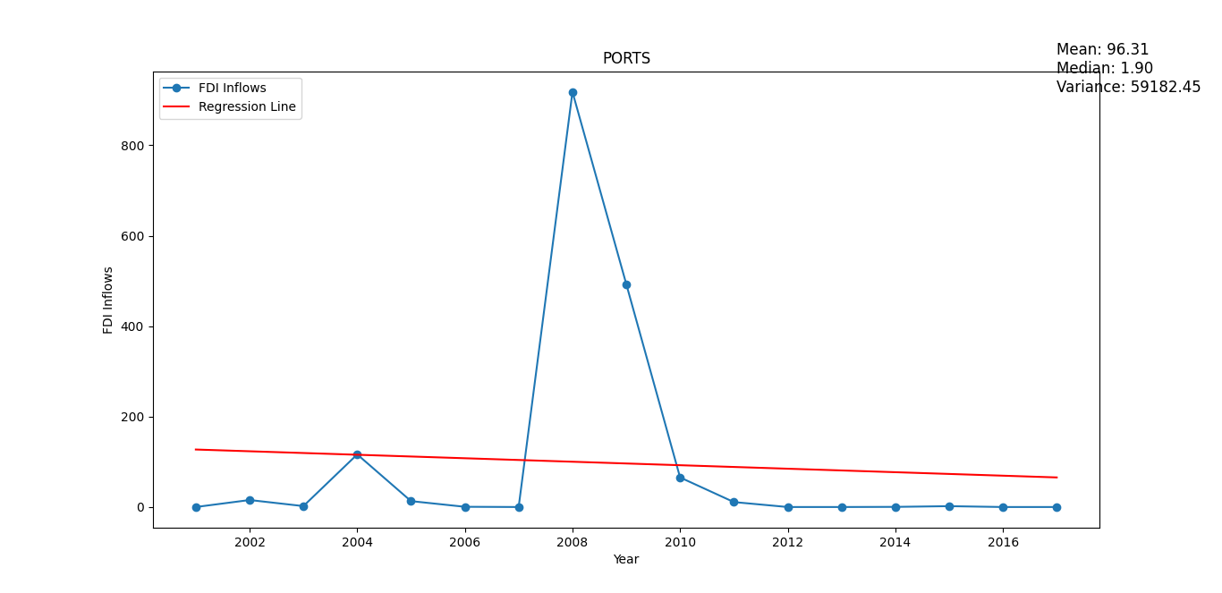

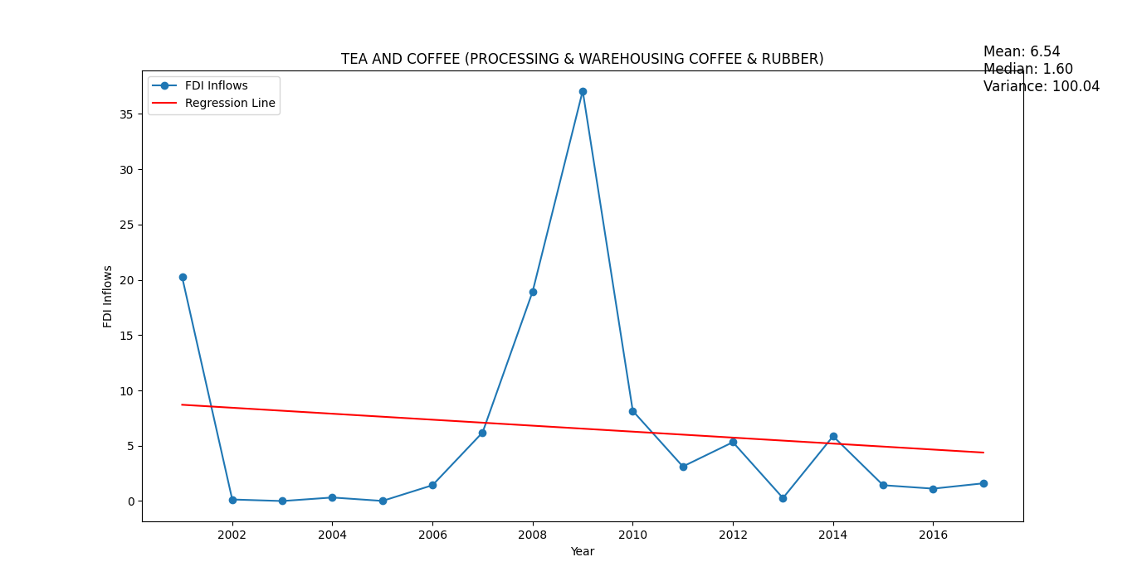

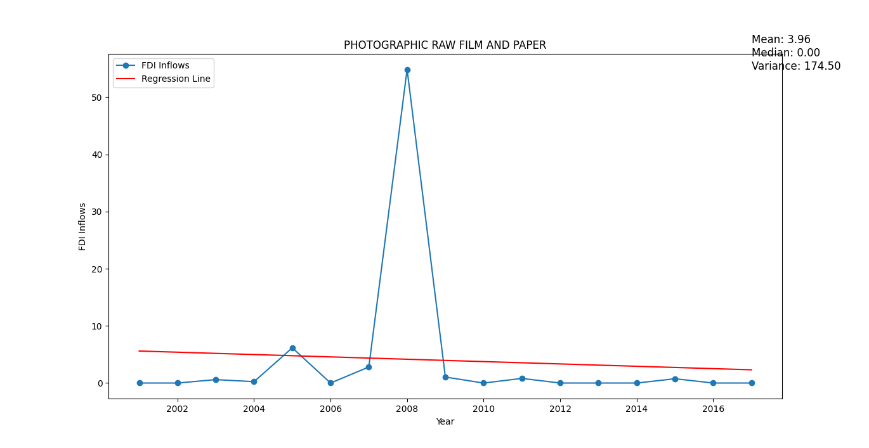

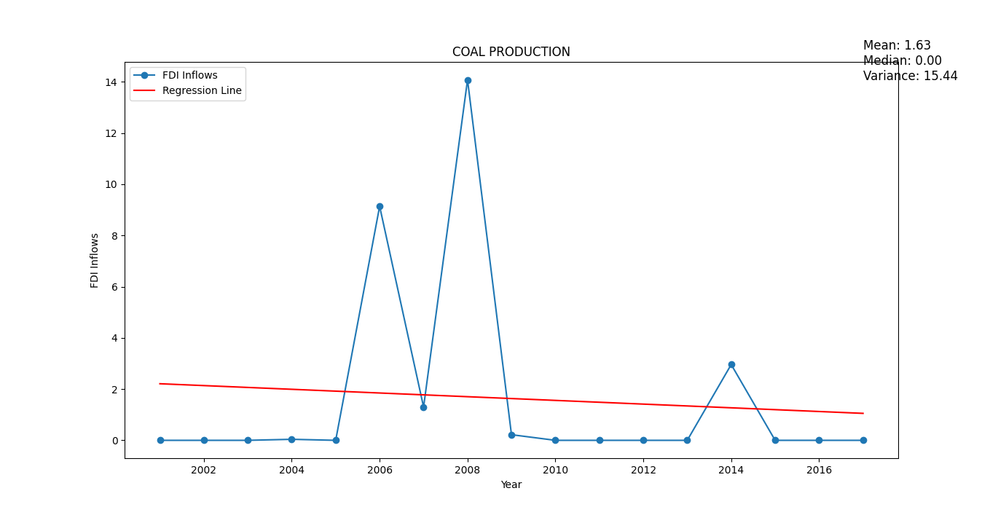

1. Correlation Analysis:

This is to identify the top 5 most correlated sectors and simultaneously look at the time series plots:

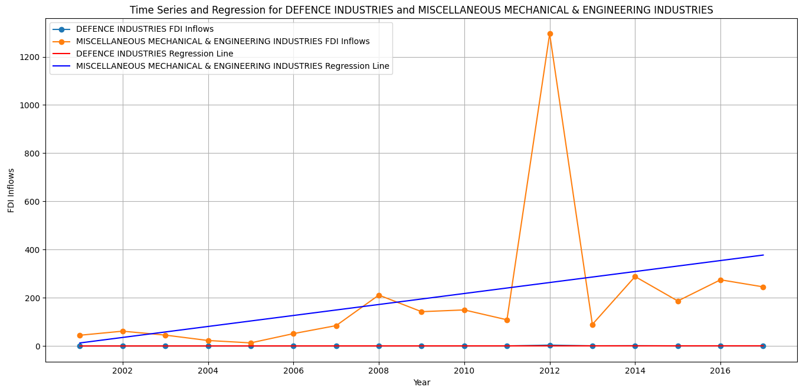

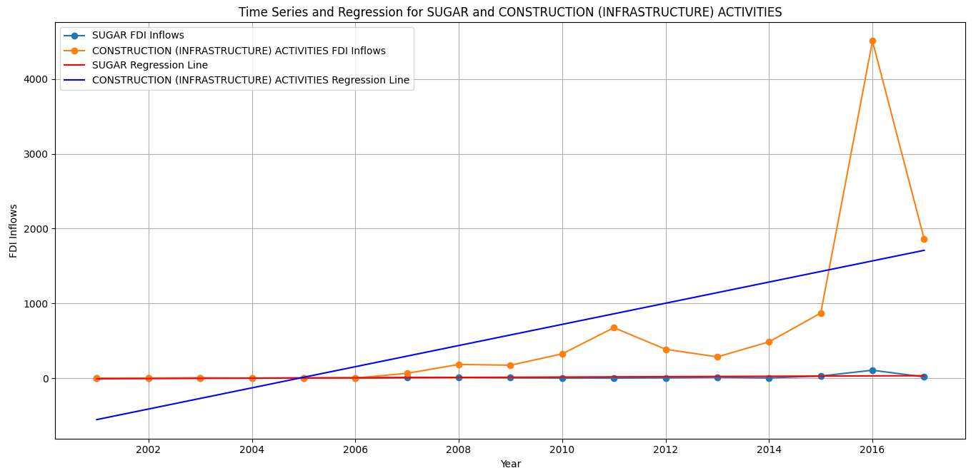

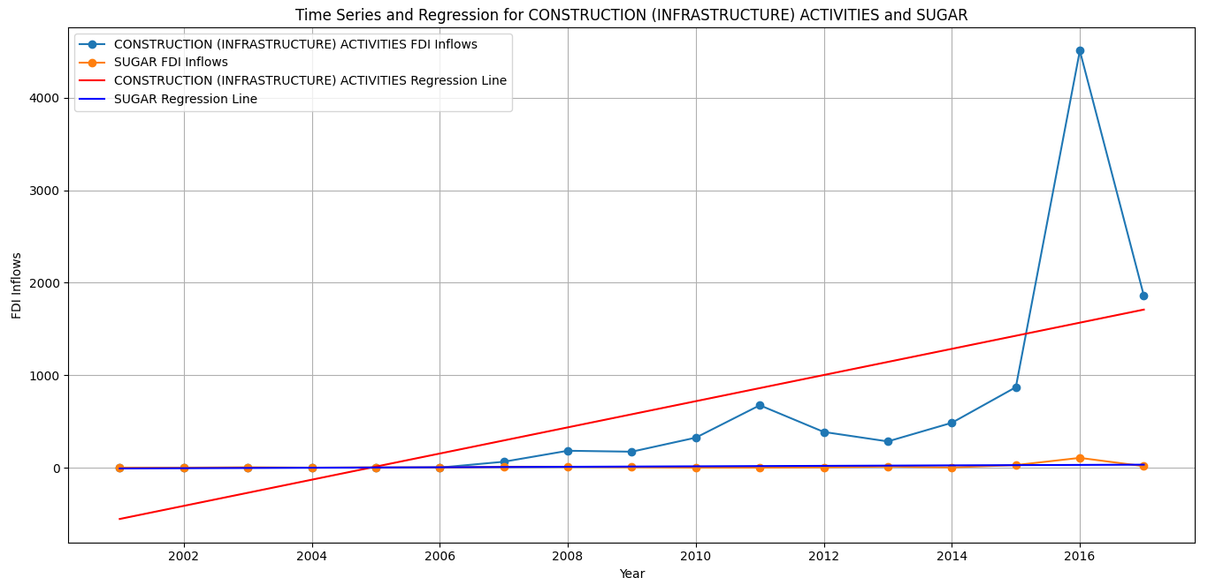

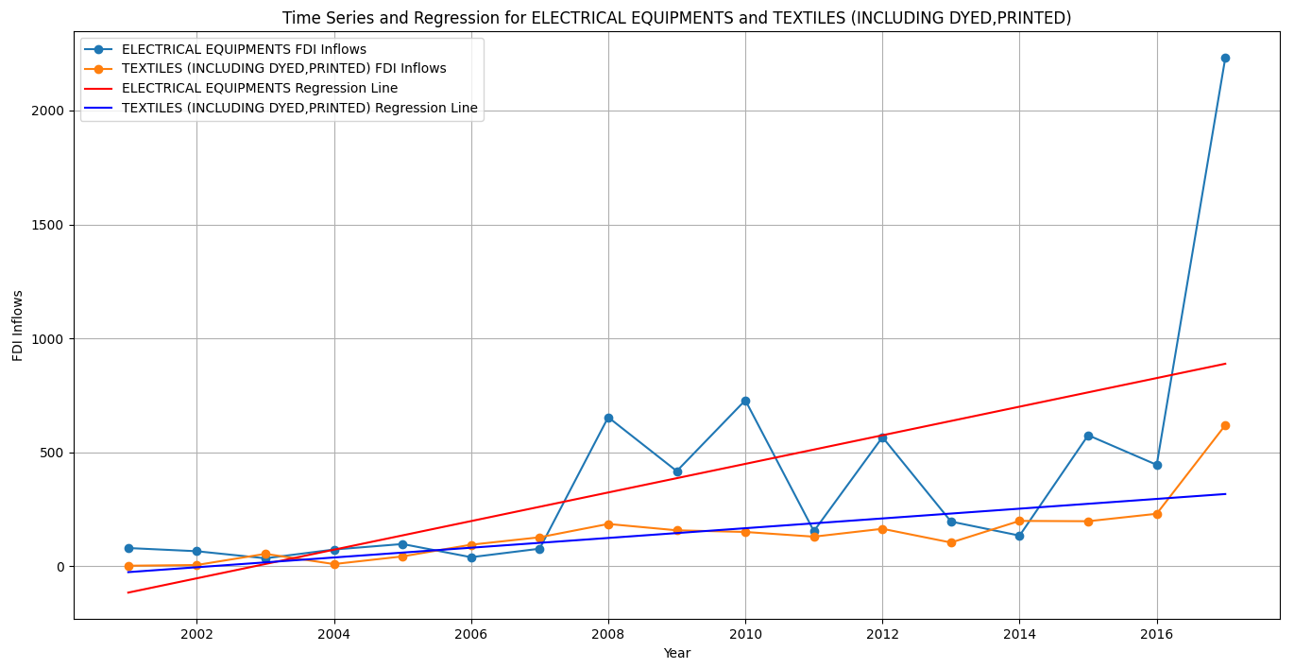

1. Clustering Analysis:

This is to identify the clusters of sectors which attract the best FDI. Plotted here.